**Adaptive Staircase Procedure**

Course name- PSY310: Lab in Psychology

Date- 1/09/2023

Name- Rishitaa Joshi

Enrollment no.- AU2120095

**GITHUB:**

**Introduction**

The adaptive staircase procedure is used to measure the minimum intensity value of the stimulus for detection. This procedure can be used in orientation and discrimination tasks. The procedure adjusts the stimuli in response to a subject’s performance. This procedure is adaptive because the physical and visual characteristics of the stimuli on each trial are determined by the stimuli and responses from the previous trials. In speech-in-noise testing, the one-up one-down adaptive (staircase or up-down) approach is frequently used to calculate the speech recognition threshold (SRT). The staircase reaches the desired stimulation level by: lowering the stimulus's intensity when several responses are right increasing stimulus amplitude after a wrong response

**Method**

***Participant***

The participant was female and the age was 20 years. The participant had normal vision and is a part of Ahmedabad University.

***Materials and Procedure***

The experiment was designed by using a python based software, Psychopy. The experimenter was provided a video explaining how to design the visual grating task by the professor of the course. The materials used by the experimenter was their personal laptop

In the task a stimulus of 1 second was added in the beginning, after which a polygon in the shape of a cross was added whose duration was 1 second. Finally a grating stimulus was added whose location was variable. Thus the participant’s main task was to click the left arrow key when the grating appeared to be inclined on the left side and click the right arrow key when the grating appeared to be inclined towards the right side. The experiment consisted of 50 trials. The experiment was conducted on a laptop in a well lit room. A python code was added at the beginning of the routine and at the end of the routine. The python code would determine how the stimuli would occur.

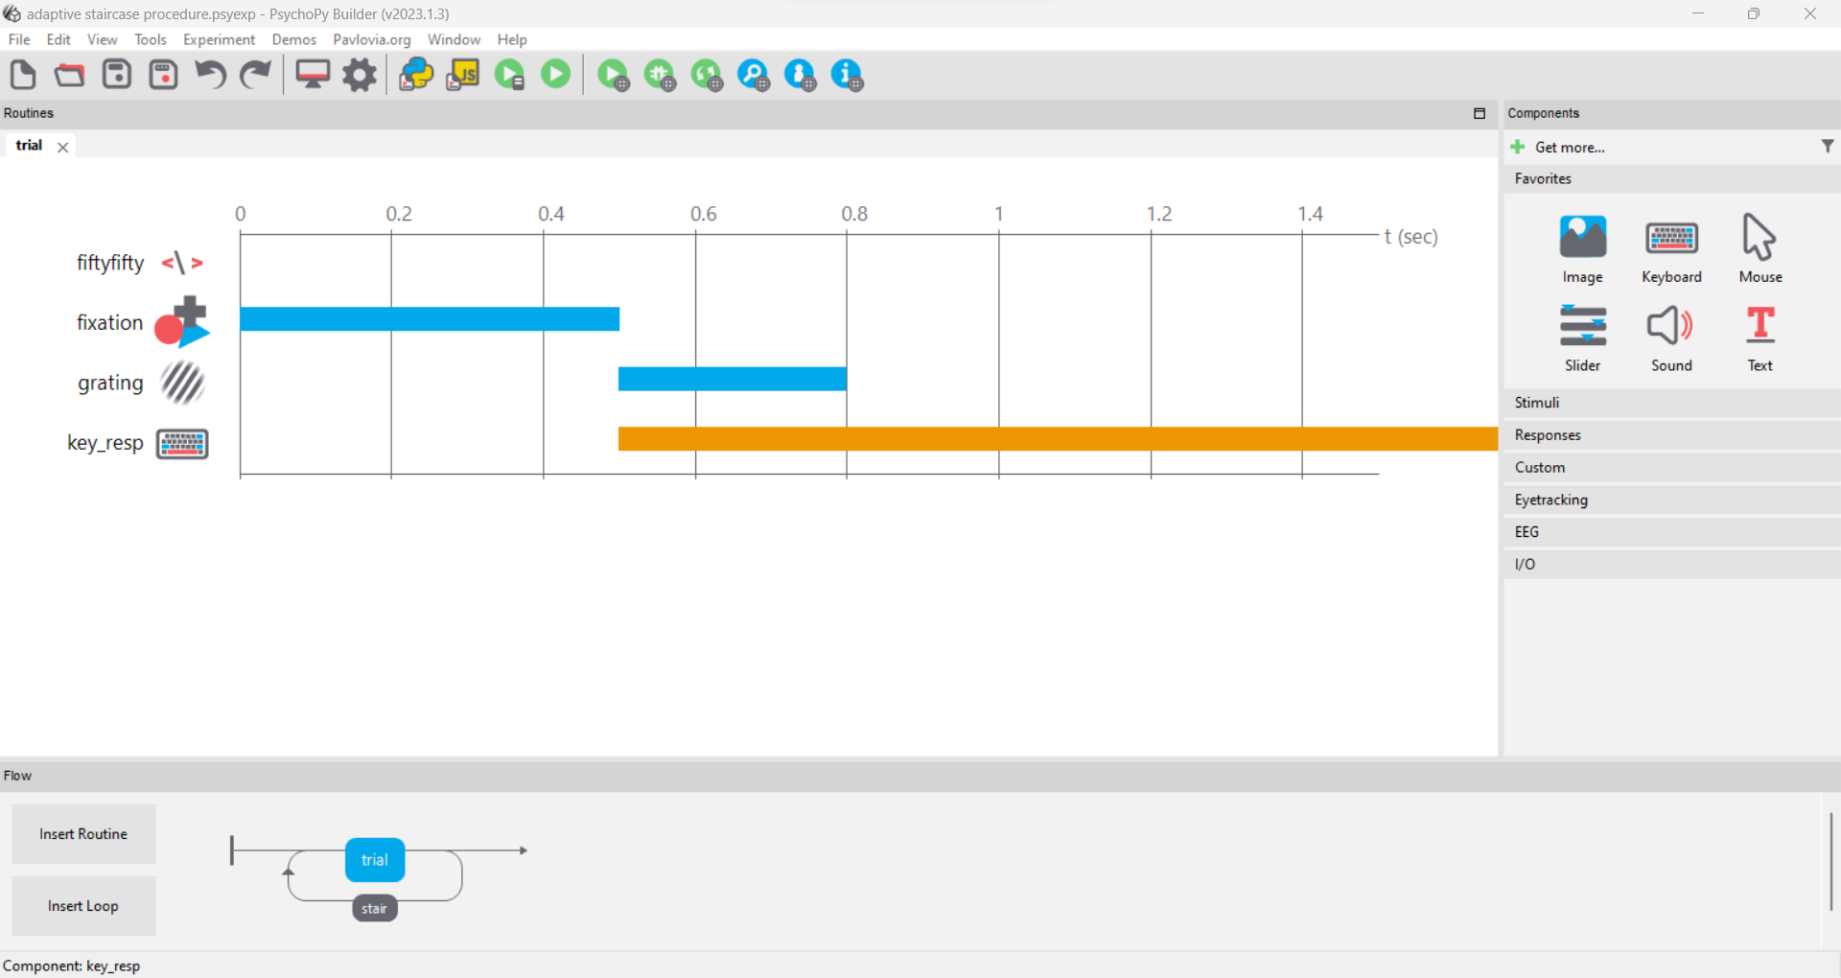

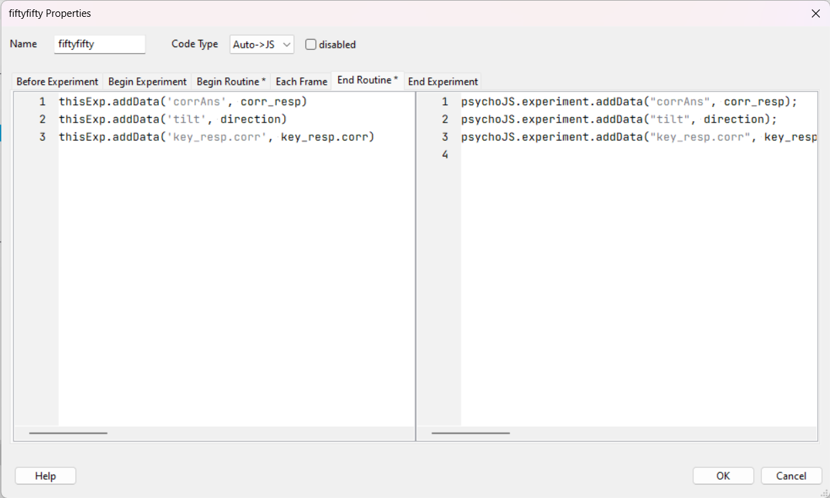

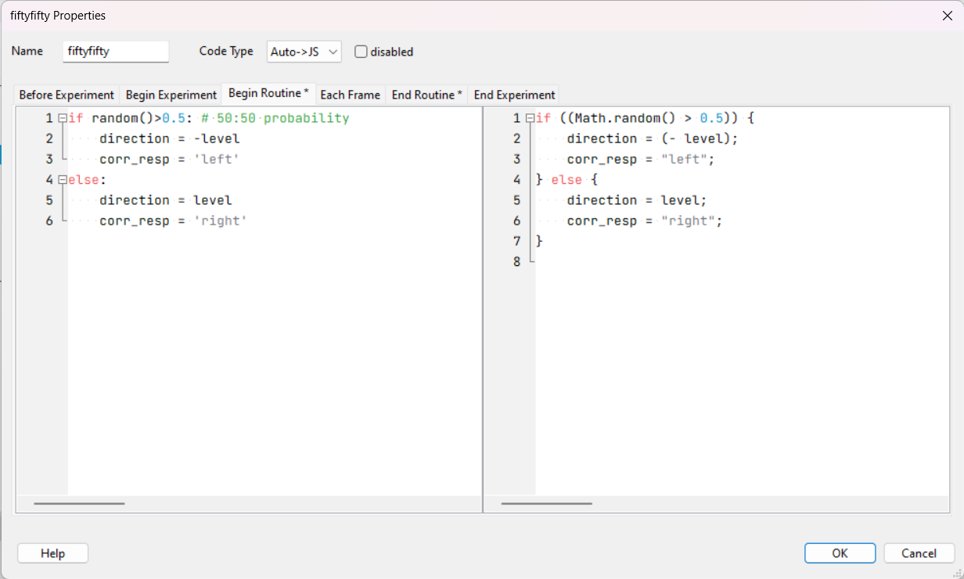

**Results**

The threshold value was found through finding the average of the last ten values of the intensity of the tilt. The value was found to be -6.

**Discussion**

The adaptive staircase procedure can estimate a participant's threshold with relatively few trials compared to traditional fixed-stimulus methods. This efficiency is particularly valuable when participants' time and attention need to be conserved. Another benefit of using the adaptive staircase procedure is that it can adapt to individual differences in performance which makes it more suitable for a wider range of participants who have varying levels of skills. A limitation of adaptive staircase procedure is that they can be more complex and difficult to design and set up and administer as compared to fixed stimulus methods. Another limitation of adaptive staircase procedure is that when comparing results across studies or between participants, the use of different adaptive procedures or parameter settings can make it challenging to draw meaningful comparisons.

**References**

*Cornsweet, T. N. (1962). The Staircase-Method in Psychophysics. The American Journal of Psychology, 75(3), 485–491. https://doi.org/10.2307/1419876*